TEST 2
SECTION 1
Questions 1 – 10
Complete the notes below.
Write ONE WORD AND/OR A NUMBER for each answer.

Enquiry about joining Youth Council
Example
Name: Roger ………..Brown…………
Age: 18
Currently staying in a 1……………. during the week
Postal address: 2 17, ……………… Street, Stamford, Lincs
Postcode: 3……………..
Occupation: student and part-time job as a 4……………..
Studying 5…………… (major subject) and history (minor subject)
Hobbies: does a lot of 6……………., and is interested in the 7……………..
On Youth Council, wants to work with young people who are 8……………..
Will come to talk to the Elections Officer next Monday at 9…………….. pm
Mobile number: 10……………

SECTION 2
Questions 11 – 20
New staff at theatre
Questions 11 and 12
Choose TWO letters, A-E.
Which TWO changes have been made so far during the refurbishment of the theatre?
A Some rooms now have a different use.
B A different type of seating has been installed.
C An elevator has been installed.
D The outside of the building has been repaired.
E Extra seats have been added.

Questions 13 and 14
Choose TWO letters, A-E.
Which TWO facilities does the theatre currently offer to the public?
A rooms for hire
B backstage tours
C hire of costumes
D a bookshop
E a café

Questions 15 and 16
Choose TWO letters, A-E.
Which TWO workshops does the theatre currently offer?
A sound
B acting
C making puppets
D make-up
E lighting

Questions 17-20
Label the plan below.
Write the correct letter, A-G, next to Questions 17-20.
Ground floor plan of theatre
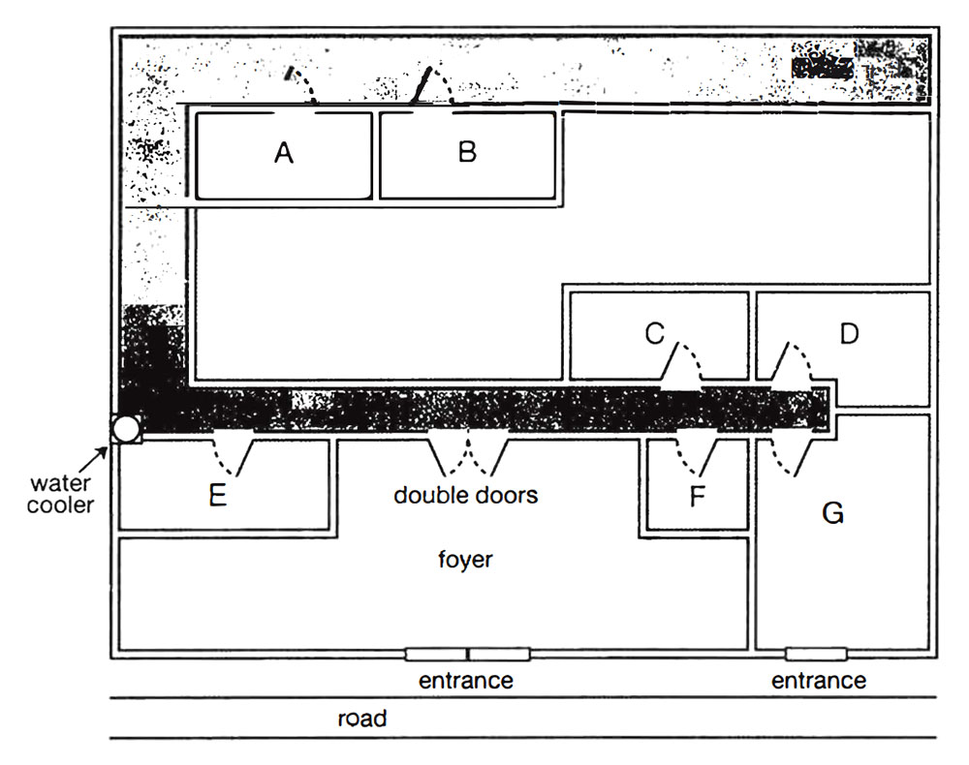

17 box office …………….
18 theatre manager’s office …………….
19 lighting box …………….
20 artistic director’s offices …………….

SECTION 3
Questions 21 – 26
Choose the correct letter, A, B or C.
Rocky Bay field trip
21 What do the students agree should be included in their aims?
A factors affecting where organisms live
B the need to preserve endangered species
C techniques for classifying different organisms
22 What equipment did they forget to take on the Field Trip?
A string
B a compass
C a ruler
23 In Helen’s procedure section, Colin suggests a change in
A the order in which information is given.
B the way the information is divided up.
C the amount of information provided.
24 What do they say about the method they used to measure wave speed?
A It provided accurate results.
B It was simple to carry out.
C It required special equipment.
25 What mistake did Helen make when first drawing the map?
A She chose the wrong scale.
B She stood in the wrong place.
C She did it at the wrong time.
26 What do they decide to do next with their map?
A scan it onto a computer
B check it using photographs
C add information from the internet

Questions 27 and 28
Choose TWO letters, A-E.
Which TWO problems affecting organisms in the splash zone are mentioned?
A lack of water
B strong winds
C lack of food
D high temperatures
E large waves

Questions 29 and 30
Choose TWO letters, A-E.
Which TWO reasons for possible error will they include in their report?
A inaccurate records of the habitat of organisms
B influence on behaviour of organisms by observer
C incorrect identification of some organisms
D making generalisations from a small sample
E missing some organisms when counting

SECTION 4
Questions 31 – 40
Complete the notes below.
Write ONE WORD ONLY for each answer.
DESIGNING A PUBLIC BUILDING:
THE TAYLOR CONCERT HALL
Introduction
The designer of a public building may need to consider the building’s
● function
● physical and 31…………….. context
● symbolic meaning
Location and concept of the Concert Hall
On the site of a disused 32………………
Beside a 33………………
The design is based on the concept of a mystery
Building design
It’s approached by a 34……………… for pedestrians
The building is the shape of a 35……………….
One exterior wall acts as a large 36………………
In the auditorium:
● the floor is built on huge pads made of 37………………
● the walls are made of local wood and are 38……………… in shape
● ceiling panels and 39………………. on walls allow adjustment of acoustics
Evaluation
Some critics say the 40…………….. style of the building is inappropriate

